40.36: Using the normalized wave function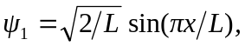the probabilities
